Bank Database — ACID Properties & Transaction Isolation

SQL PRACTICAL / LAB EXERCISE
Name: Teja Hasini Reddy
Roll No: 2520030048

Section: 7
Email: tejahasinireddy@klh.edu.in

Step 1 — Create Database
CREATE DATABASE Bank_ACID_DB;
USE Bank_ACID_DB;

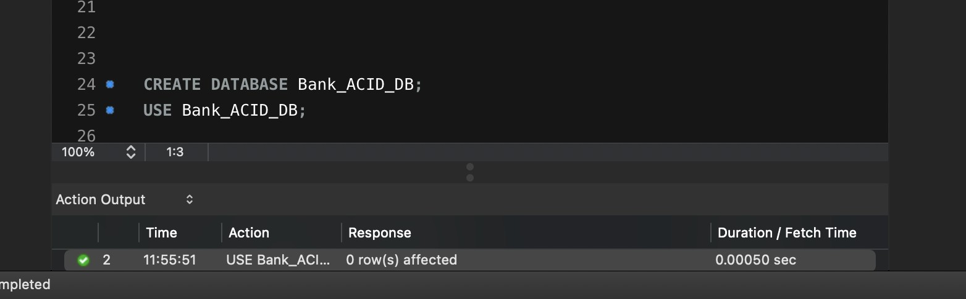

Step 2 — Create Customer Table
CREATE TABLE Customer ( Customer_ID INT PRIMARY KEY,
Customer_Name VARCHAR(100) NOT NULL, Phone VARCHAR(15),
City VARCHAR(50)
);

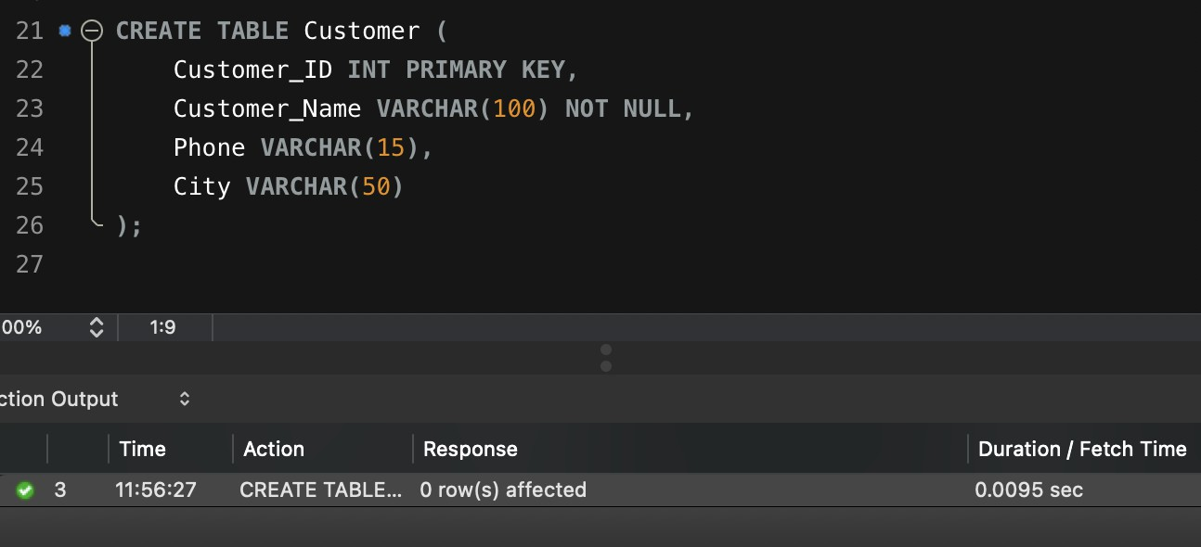

\Step 3 — Create Account Table (FOREIGN KEY)
CREATE TABLE Account ( Account_No INT PRIMARY KEY, Customer_ID INT, Account_Type VARCHAR(20), Balance DECIMAL(12,2), Branch VARCHAR(50),
FOREIGN KEY (Customer_ID) REFERENCES Customer(Customer_ID)
);

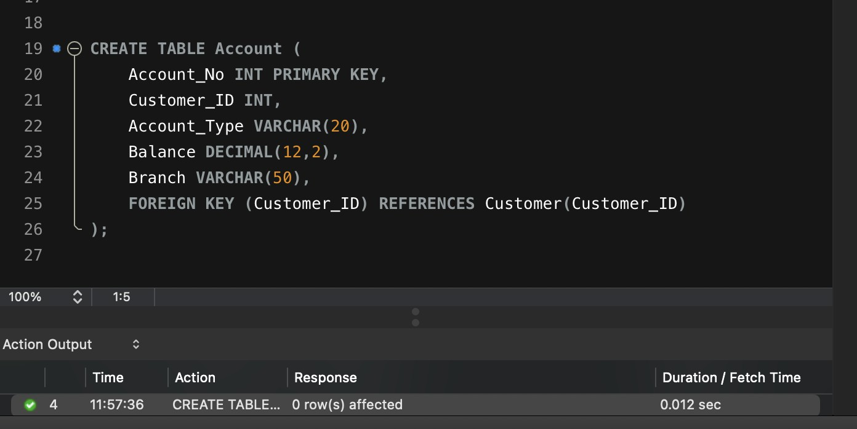

Step 4 — Insert Customer & Account Data, Then Display
INSERT INTO Customer (Customer_ID, Customer_Name, Phone, City) VALUES
INSERT INTO Account (Account_No, Customer_ID, Account_Type, Balance, Branch)
VALUES
SELECT * FROM Customer;
SELECT * FROM Account;

(101, | 'Teja Hasini Reddy', '9876543210', 'Hyderabad'),
(102, | 'Priya Sharma', '9876543211', 'Vijayawada'),
(103, | 'Arjun Reddy', '9876543212', 'Bangalore'),
(104, | 'Sneha Rao', '9876543213', 'Chennai'),
(105, | 'Kiran Kumar', '9876543214', 'Hyderabad');

(10001, | 101, | 'Savings', | 50000, 'Hyderabad'),
(10002, | 102, | 'Savings', | 75000, 'Vijayawada'),
(10003, | 103, | 'Current', | 120000, 'Bangalore'),
(10004, | 104, | 'Savings', | 45000, 'Chennai'),
(10005, | 105, | 'Current', | 90000, 'Hyderabad');

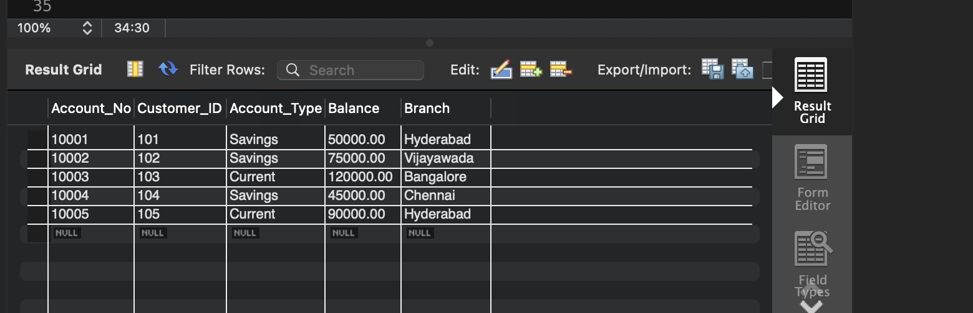

Step 5 — Deposit Transaction (COMMIT)
START TRANSACTION;
UPDATE Account
SET Balance = Balance + 5000 WHERE Account_No = 10001;
SELECT * FROM Account WHERE Account_No = 10001; COMMIT;
SELECT * FROM Account WHERE Account_No = 10001;

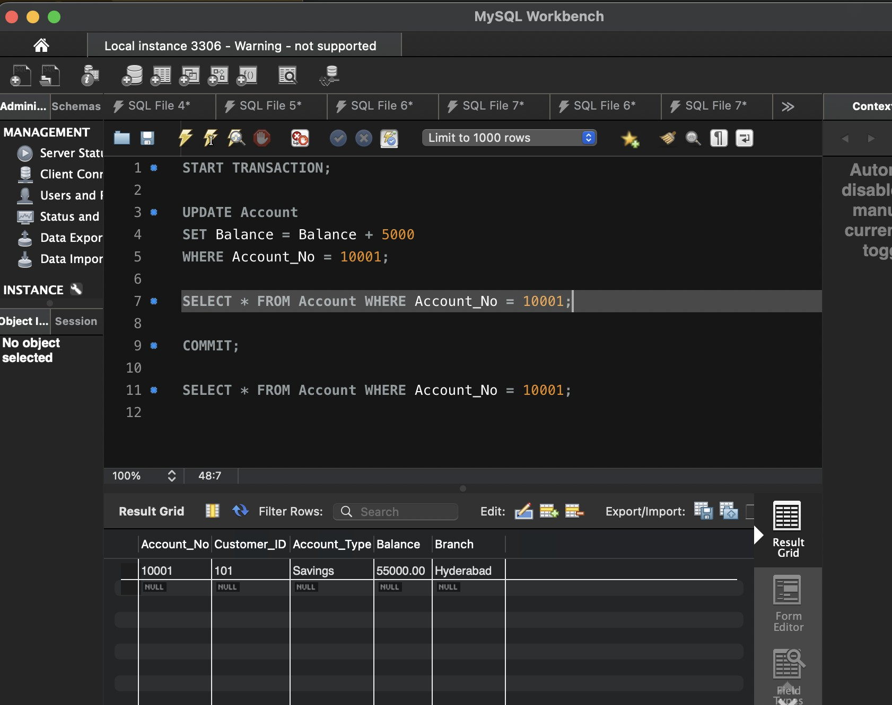

Step 6 — Withdraw Transaction (ROLLBACK)
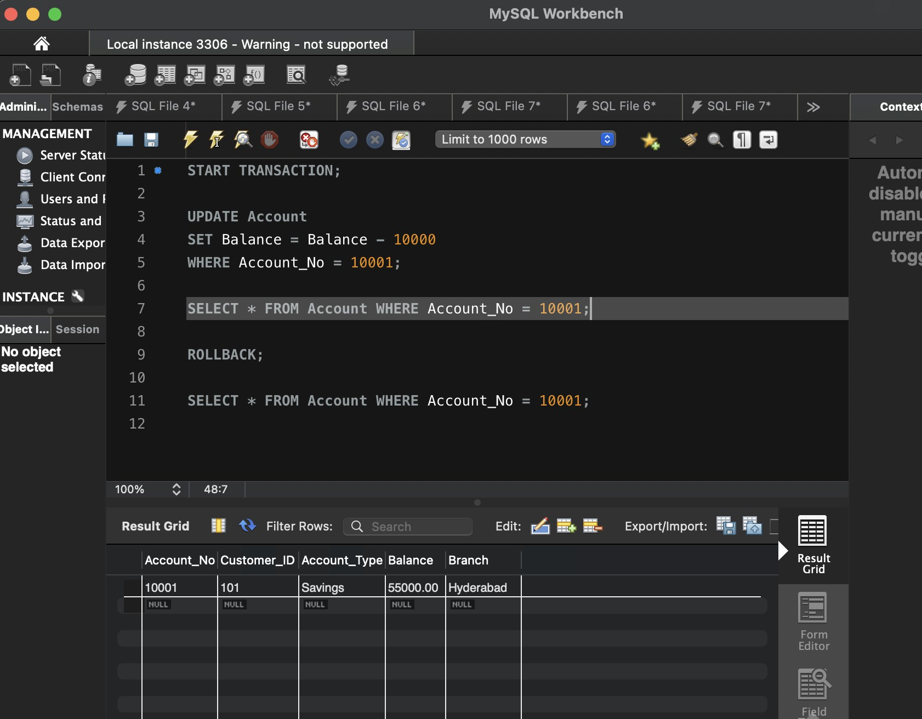
START TRANSACTION;
UPDATE Account
SET Balance = Balance - 10000 WHERE Account_No = 10001;
SELECT * FROM Account WHERE Account_No = 10001; ROLLBACK;
SELECT * FROM Account WHERE Account_No = 10001;

Step 7 — SAVEPOINT Demonstration
START TRANSACTION;
UPDATE Account SET Balance = Balance + 5000 WHERE Account_No = 10001; SAVEPOINT Deposit1;
UPDATE Account SET Balance = Balance - 3000 WHERE Account_No = 10002; SAVEPOINT Withdrawal1;

UPDATE Account SET Balance = Balance + 10000 WHERE Account_No = 10003; ROLLBACK TO SAVEPOINT Withdrawal1;
COMMIT;
SELECT * FROM Account;

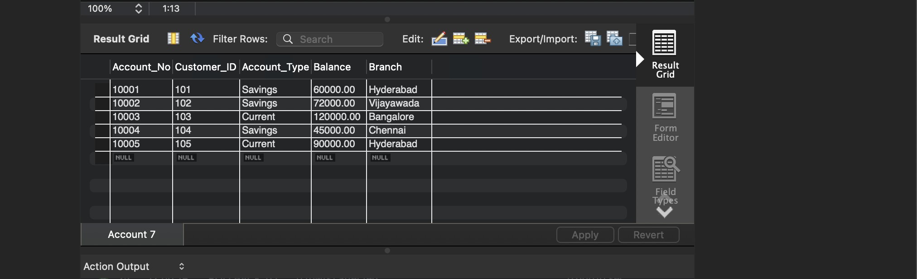

Step 8 — Bank Transfer (Demonstrates ATOMICITY)
START TRANSACTION;
UPDATE Account SET Balance = Balance - 10000 WHERE Account_No = 10001; UPDATE Account SET Balance = Balance + 10000 WHERE Account_No = 10002; SELECT * FROM Account WHERE Account_No IN (10001,10002);
COMMIT;

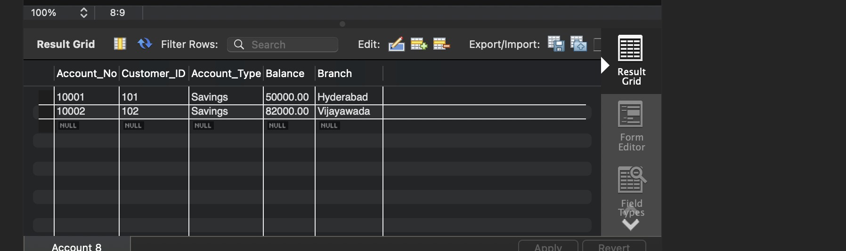

Step 9 — Check Current Transaction Isolation Level
SELECT @@SESSION.transaction_isolation;

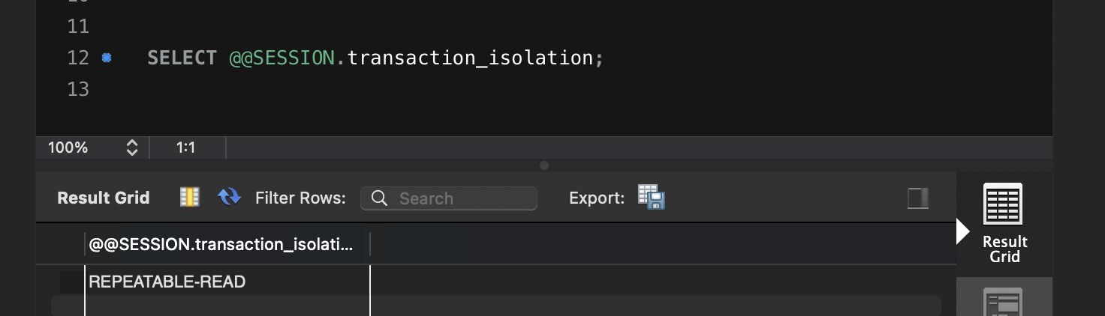

Step 10 — Change Isolation Level to READ COMMITTED
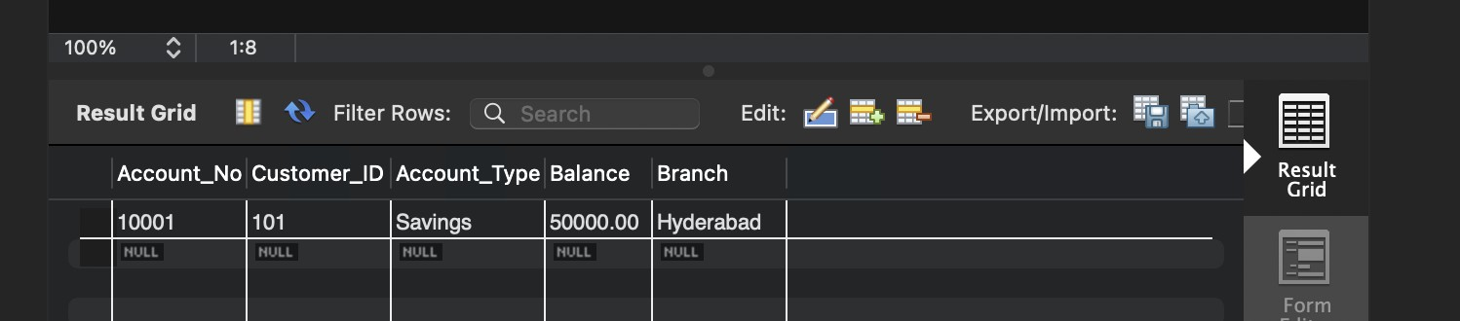
SET SESSION TRANSACTION ISOLATION LEVEL READ COMMITTED; START TRANSACTION;
SELECT * FROM Account WHERE Account_No = 10001;
COMMIT;

